|  |
| --- |
| Experiment No. 4 |
| Creating functions, classes and objects using python |
| Date of Performance:12/2/2024 |
| Date of Submission:19/2/2024 |

**Experiment No. 4**

**Title:** Creating functions, classes and objects using python

**Aim:** To study and create functions, classes and objects using python

**Objective:** To introduce functions, classes and objects in python **Theory:**

A function is a block of code which only runs when it is called.

You can pass data, known as parameters, into a function.

A function can return data as a result.

A class is a user-defined blueprint or prototype from which objects are created. Classes provide a means of bundling data and functionality together. Creating a new class creates a new type of object, allowing new instances of that type to be made. Each class instance can have attributes attached to it for maintaining its state. Class instances can also have methods (defined by their class) for modifying their state.

To understand the need for creating a class let’s consider an example, let’s say you wanted to track the number of dogs that may have different attributes like breed, age. If a list is used, the first element could be the dog’s breed while the second element could represent its age. Let’s suppose there are 100 different dogs, then how would you know which element is supposed to be which? What if you wanted to add other properties to these dogs? This lacks organization and it’s the exact need for classes.

Class creates a user-defined data structure, which holds its own data members and member functions, which can be accessed and used by creating an instance of that class. A class is like a blueprint for an object.

**Code:** class Student:

def __init__(self, name, marks):

self.name = name self.marks = marks def calculate_grade(self):

if self.marks >= 80:

return 'A' elif 70 <= self.marks < 80: return 'B' elif 60 <= self.marks < 70: return 'C' elif 50 <= self.marks < 60:

return 'D' else:

return 'F'

num_students = 5

students_list = []

for i in range(num_students):

name = input(f"Enter the name of student {i + 1}: ") marks = float(input(f"Enter the marks of {name}: ")) student = Student(name, marks) students_list.append(student) print("\nStudent Grades:") for student in students_list:

grade = student.calculate_grade() print(f"{student.name}: {grade}") **Output:**

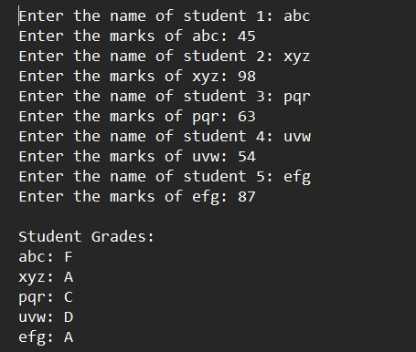

**Conclusion:**Classes, functions, and objects constitute fundamental elements in Python programming. Classes serve as blueprints for creating objects with attributes and methods, facilitating code organization and reuse. Functions encapsulate blocks of code for specific tasks, enhancing modularity and readability. Objects are instances of classes, representing real-world entities or concepts, and encapsulate data and behavior. Together, these elements enable the implementation of object-oriented programming principles, promoting code clarity, maintainability, and scalability in Python applications.